3GPP TSG-RAN WG4 Meeting #119 R4-2606992
Dalian, CN, May 18 - 22, 2026

Title: Discussions on 6G sensing feasibility study
Source: OPPO
Agenda item: 8.10.3
Document for: Approval
- Introduction
It was agreed to keep discussing 6G sensing agenda in RAN4 #116bis meeting [1]. And the topics on 6G sensing were preliminary discussed during RAN4 #117 and #118 meetings. In RAN4 #118bis meeting, a significant progress was achieved on several topics to make the work group more focused. This paper provides our views on the topic of 6G sensing feasibility study for TRP-UE and/or UE-TRP bi-static mode.

- Discussion
Two sub-topics will be discussed in this paper, i.e. frequency bands for sensing and the dynamic range of UE receiver in TRP-UE bi-static sensing mode.

  - Frequency bands for 6G sensing
Regarding the frequency bands, the following agreement [2] is achieved by down-selecting from two options.

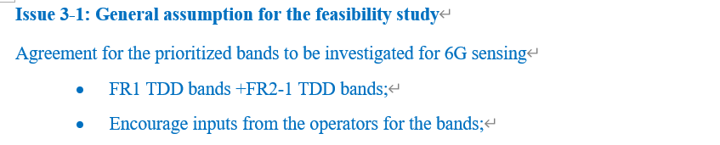

Meanwhile, RAN1 has reached more detailed conclusions on frequency bands for 6G sensing performance evaluation in RAN1 #124bis meeting [3], i.e. 4GHz, around 7GHz and 30GHz.

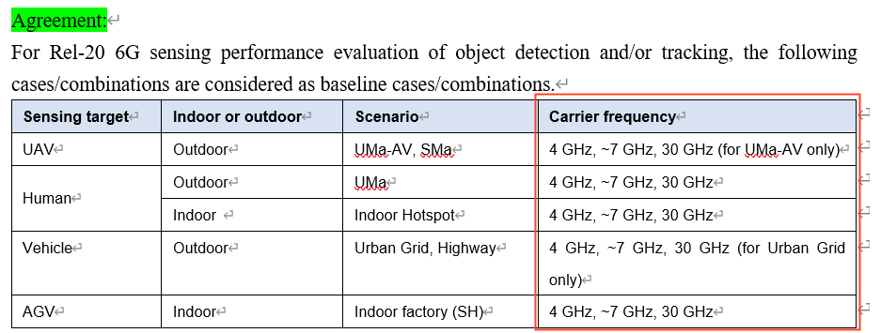

The three carrier frequencies selected by RAN1 correspond to sub6G, U6G, and mmW, which can represent the three typical frequency ranges of mobile communication, i.e. FR1, new frequency range and FR2. The frequency bands relative to the RAN1 selected carrier frequencies can be further derived. For 4GHz, there is only one band within the frequency range of 4-5GHz, i.e. n79. For around 7GHz, the frequency bands are not defined, and may further rely on ITU’s output. Currently, for feasibility study purpose, a 400MHz frequency range can be considered, e.g. 7GHz-7.4GHz. For 30GHz, the frequency band can be selected from n257, n258 and n261.

- The following frequency bands can be considered as 6G sensing feasibility study as the starting point.
- 4GHz: n79
- ~7GHz: a 400MHz frequency range for initial study, e.g. 7GHz-7.4GHz
- 30GHz: selected from n257, n258 and n261

  - Dynamic range of sensing node’s receiver
The agreement achieved on feasibility study of bi-static sensing mode in RAN4 #118bis meeting are captured as below [2].

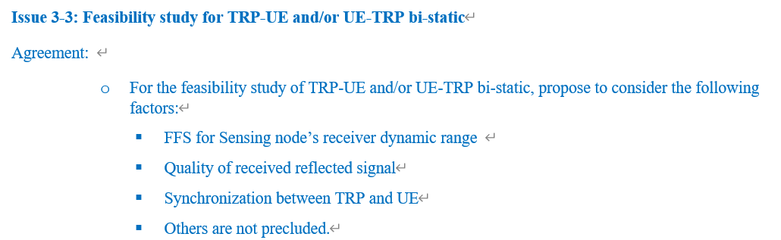

Meanwhile, the use cases together with sensing modes for mono-static and bi-static are agreed as below [2].

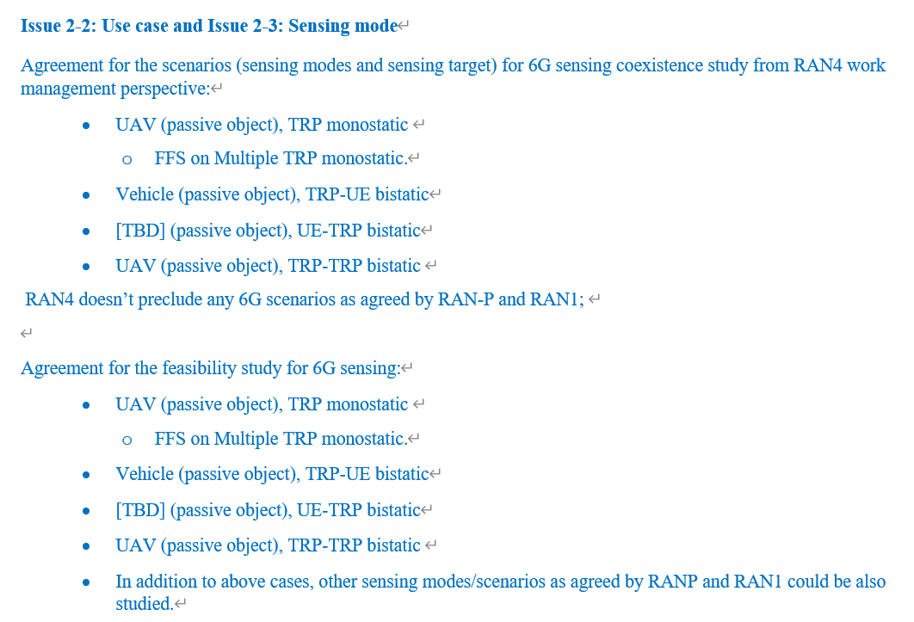

Due to the use case for UE-TRP bi-static mode is TBD, we focus to discuss TRP-UE bi-static mode for sub-6G frequency in this paper. In TRP-UE bi-static mode, TRP is the transmitting node, and UE serves as the receiving node. As a receiving node, not transmitting sensing RS signal, UE is expected to reuses the same RF front-end components in the receiving chain as that exist for 6GR communication. So, the dynamic range of UE reception for both sensing and communication can refer to 5G specifications. In detail, the lower limit of receiving dynamic range corresponds to the reference sensitivity power level in Clause 7.3 of TS 38.101-1. And the upper limit of receiving dynamic range is the maximum input level in Clause 7.4 of TS 38.101-1. For n79, taking 100MHz as channel bandwidth, the lower limit of dynamic range is -85.5dBm, and the upper limit is -20dBm. For convenience, the reference sensitivity power level and the maximum input level are captured as below.

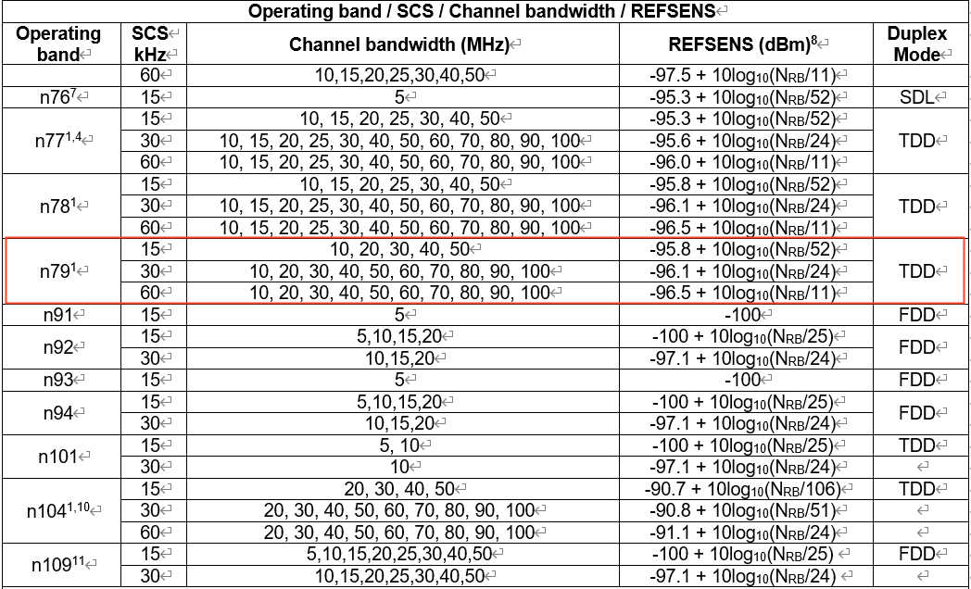

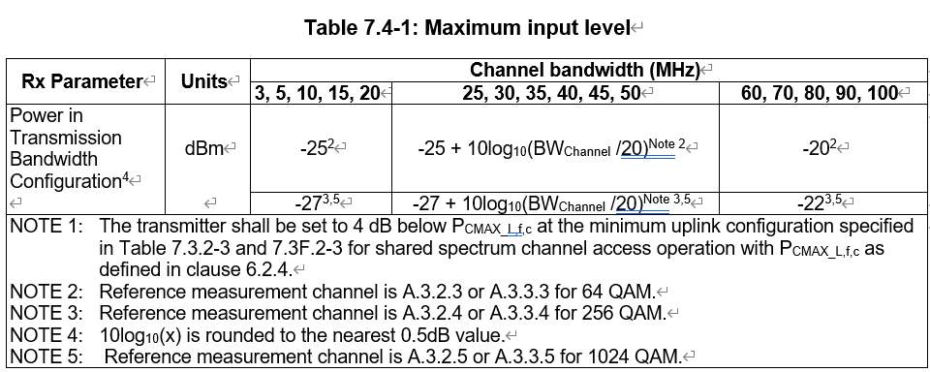

- Consider -85.5dBm ~ -20dBm as the receiving dynamic range when UE serves as the receiving node in TRP-UE bi-static mode.

- Conclusion
This paper provides our views on the topic of 6G sensing feasibility study for TRP-UE and/or UE-TRP bi-static mode.

- The following frequency bands can be considered as 6G sensing feasibility study as the starting point.
- 4GHz: n79
- ~7GHz: a 400MHz frequency range for initial study, e.g. 7GHz-7.4GHz
- 30GHz: selected from n257, n258 and n261
- Consider -85.5dBm ~ -20dBm as the receiving dynamic range when UE serves as the receiving node in TRP-UE bi-static mode.

- Reference
- R4-2514592 WF on 6G Sensing, ZTE Corporation
- R4-2604942 Way Forward for [118bis][362] 6G_Sensing, ZTE Corporation
- Draft_Minutes_report_RAN1#124b_v050

